nATIONAL sAFE motherhood day 2022.

Department of Obstetrics & Gynaecology Nursing ,College of Nursing,
All India Institute of Medical Sciences, Raipur
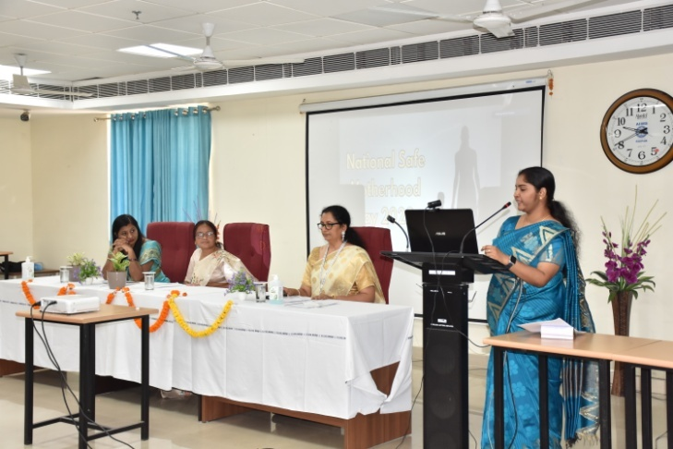 | 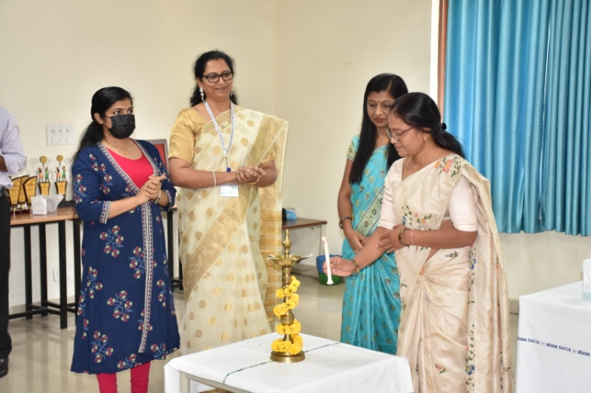
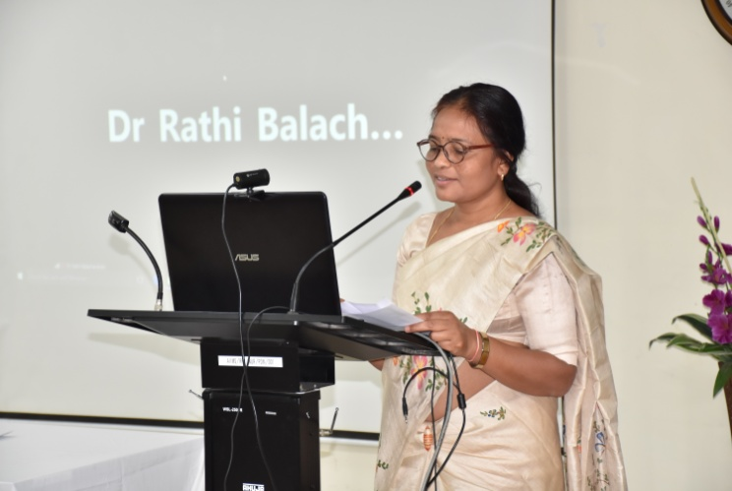 | 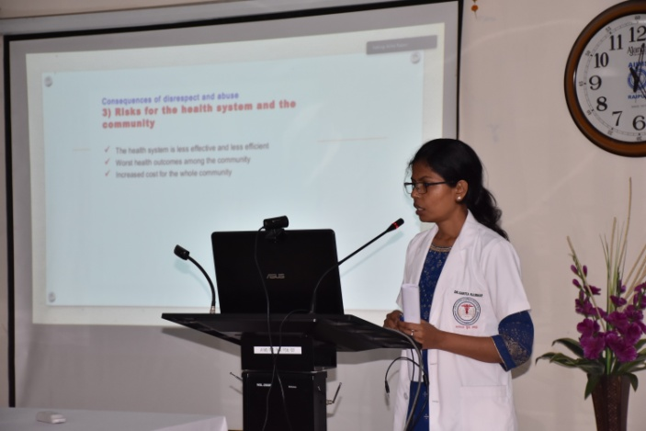
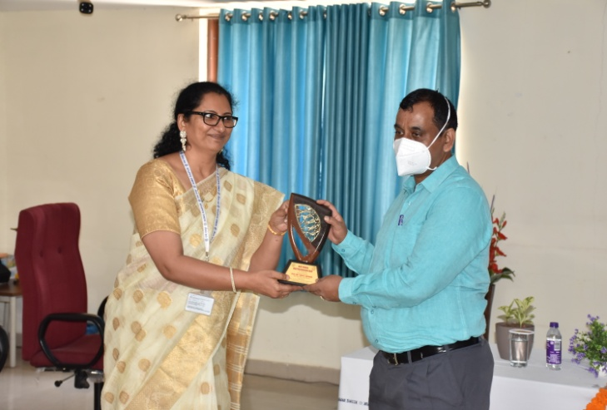 | 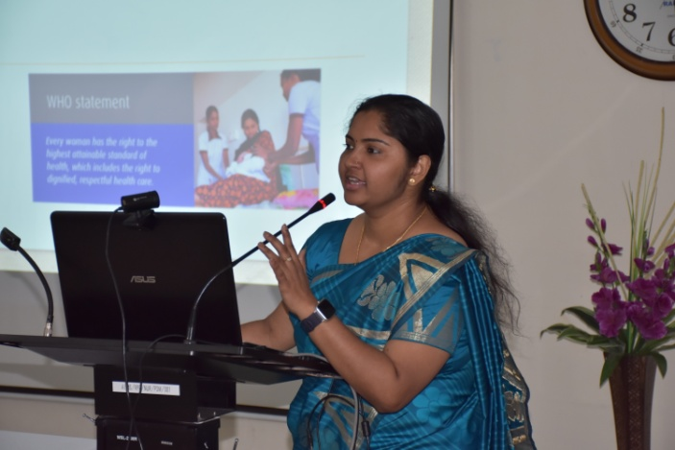

National Safe Motherhood Day was observed by Department of Obstetrics & Gynaecology Nursing, College of Nursing, AIIMS Raipur, on 11th April 2022 which was inagurated by Ms. Durgawati Kunjam, Registrar, CG Nursing Registration Council. Dr. Rathi Balachandran, ADG (Nursing), MoHFW , Government of India delivered key note address. Dr.Binu Mathew Assistant Professor ,College of Nursing welcomed the gathering & Mrs.Jissa Donel ,Nursing Tutor College of Nursing unfolded the theme.
With an aim to decrease these statistics and improve Maternal Mortality Rate (MMR) in India, along with raising awareness about adequate access to care during pregnancy, childbirth and postnatal services, India marks April 11 as the National Safe Motherhood Day. In India, National Safe Motherhood Day also aims to help country achieve the third Sustainable Development Goal (SDG), wherein countries have united to achieve a new target to accelerate the decline of maternal mortality by 2030.
A webinar (hybrid mode) was conducted for the Teaching Faculties, Assistant Nursing Superintendents, Senior Nursing officers, Nursing Officers and BSc (Hons) Nursing and MSc. Nursing students of AIIMS Raipur. Total number of delegates participated in the webinar were 150.
The resource persons of the hybrid/webinar were Ms,Sapna Thakur ,Associate Professor, Govt. College of Nursing, Durg, Dr. Rathi Balachandran, ADG (Nursing), MoHFW , Government of India, Dr.S.Vijayalakhsmi,Principal,Vignesh College of Nursing,Tiruvannamalai & Dr.Sarita Rajbhar ,Assistant Professor,Department of Obstetrics & Gynaecology, AIIMS Raipur
Sessions were on the topics on Sexual & Reproductive Health & Rights,Respectful Maternity Care, Government of India Initiatives to ensure safe motherhood & Obstetric violence.
The program was guided and supported by Honorable Prof. (Dr.) Nitin M. Nagarkar, Director & CEO, Prof (Dr.) Alok C. Agrawal, Assosciate Dean, Professor & Head Dept. of Orthopaedics and Dr. Binu Mathew and Mrs. J. Jeayareka, Assistant Professors, College of Nursing, AIIMS Raipur.

